**BUS RESERVATION SYSTEM**

Aim: Draw the use case diagram and specify the role of each of the actors. Also state the precondition, post condition and function of each use case.

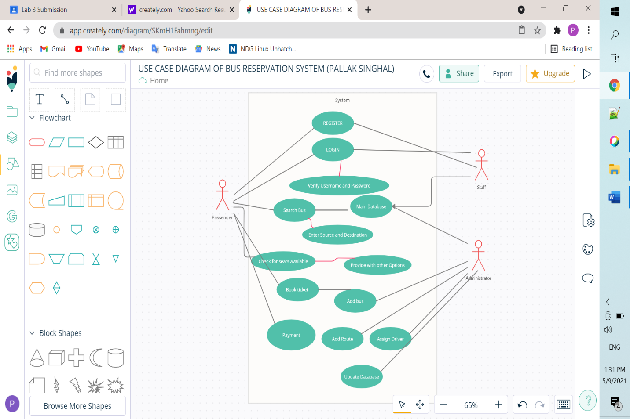

***Role of Actors:***

There are three actors present in the Bus Reservation System namely***the passenger****,* ***the staff*** *and* ***the administrator****.* Their roles are as follows-

1. **Passenger:**
2. The passenger is responsible for registering himself/herself on the platform and then using those credentials to login.
3. The passenger then searches the bus by entering the source and destination.
4. The information is fetched from the Main database of the system.
5. The seats available are displayed and the passenger can book the seat and then make the payment for the same.
6. **Staff:**
7. The staff registers itself on the system and uses the credentials to login.
8. The staff keeps the information about the buses on the system updated.
9. **Administrator:**
10. The administrator keeps an eye on the updates made by the staff like the information is incorrect.
11. The administrator can add bus numbers, new routes, assign drivers and update the overall database of the Bus Reservation System.

**Precondition, Post condition and function of use case**

Pre-conditions are the things that must be true before a method is called. The method tells clients "this is what I expect from you".

Post-conditions are the things that must be true after the method is complete. Invariants are the things that are always true and won't change.

Functions: A Use Case consists of use cases, persons, or various things that are invoking the features called as actors and the elements that are responsible for implementing the use cases. Use case diagrams capture the dynamic behavior of a live system.

It models how an external entity interacts with the system to make it work. Use case diagrams are responsible for visualizing the external things that interact with the part of the system